- We have two steps: Train and Test.
For training, the model will be trained on the AORC dataset from 1981 to 2011. The data is stored at /scratch/jl14811/AORC_1981-2011. In this directory, there are two folders, one of which is AORC_21_31, as our input. The other one is AORC_126_186, as our target.

For testing, the model will be tested on the AORC and GCM datasets from 2012 to 2014. The data is stored at /scratch/jl14811/GCM_2012-2014/, and /scratch/jl14811/AORC_2012-2014/AORC_21_31/. They will be the model’s input, and the target will be /scratch/jl14811/AORC_2012-2014/AORC_126_186/.
The training and testing codes are at /home/jl14811/AORC2AORC/. We only need to modify the parameters of the training and testing codes now. The training file is: downscaling_train.py. The testing file is: run_validation.sh.

- How to run the training:
Open the file downscaling_train.py:
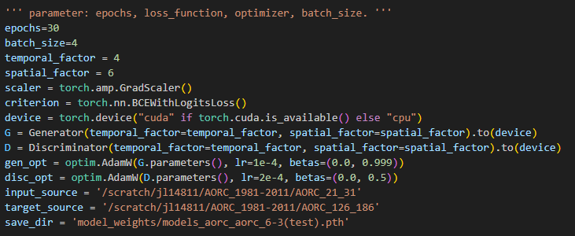
You can change the parameters in this file. Please be careful with the save_dir; this is the location where the model’s weights will be saved.
Activate the conda environment:
source ~/bashrc
conda activate /vast/jl14811/myenv
Run the train code:
python downscaling_train.py >> outlog 2>&1

- How to run the testing:
Open the file run_validation.sh
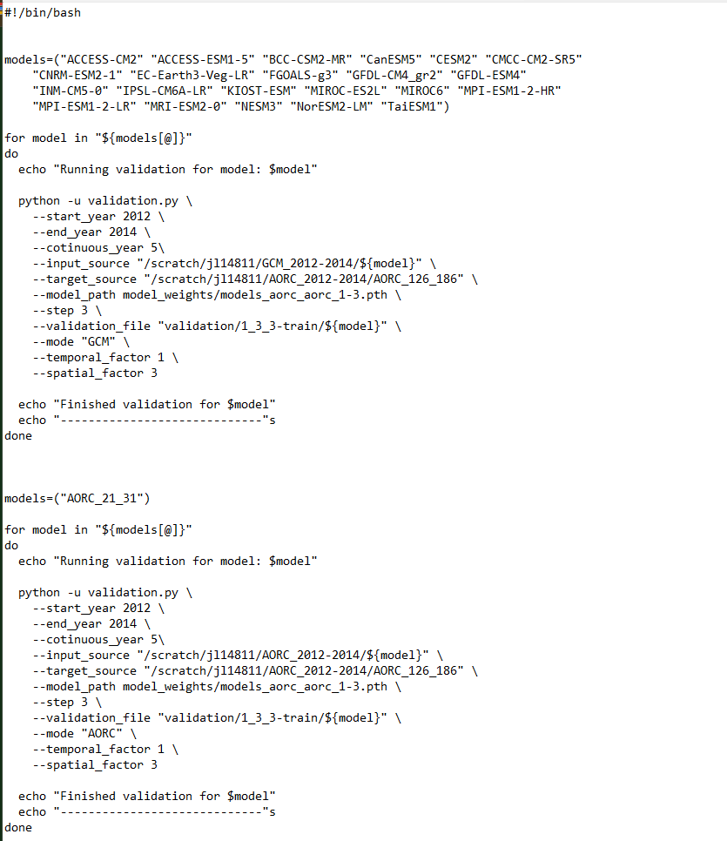
model_path: model_weights/models_aorc_aorc_1-3.pth
Here, 1 means the temporal factor is 1. 3 means the spatial factor is 3.
All the models are saved at /home/jl14811/AORC2AORC/model_weights/
Activate the conda environment:
source ~/bashrc
conda activate /vast/jl14811/myenv
Run the test code:
Bash run_validation.sh >> outlog.log 2>&1

